**Mini Project Report on**



**Face Mask Detection using Python**



**Submitted in partial fulfillment of the requirement for the award of the degree of**

**BACHELOR OF TECHNOLOGY**

**IN**

**COMPUTER SCIENCE & ENGINEERING**

**Submitted by:**

**Student Name : Ishi Agarwal** **University Roll No. : 2018842**

***Under the Mentorship of***

**Ms. Meenakshi Maindola**

**Designation- Professor**



**Department of Computer Science and Engineering**

**Graphic Era (Deemed to be University)**

**Dehradun, Uttarakhand**

**January 2023**



**CANDIDATE’S DECLARATION**

I hereby certify that the work which is being presented in the project report entitled **“Face Mask Detection using Python”** in partial fulfillment of the requirements for the award of the Degree of Bachelor of Technology in Computer Science and Engineeringof the Graphic Era (Deemed to be University), Dehradun shall be carried out by the under the mentorship of **Ms Meenakshi Maindola,Professor**, Department of Computer Science and Engineering, Graphic Era (Deemed to be University), Dehradun.

Name Ishi Agarwal University Roll no: 2018842 **signature**

**Table of Contents**

|  |  |  |
| --- | --- | --- |
| **Chapter No.** | **Description** | **Page No.** |
| Chapter 1 | Introduction | **4-5** |
| Chapter 2 | Literature Survey | **6-7** |
| Chapter 3 | Methodology | **8-11** |
| Chapter 4 | Result and Discussion | **12-13** |
| Chapter 5 | Conclusion and Future Work | **14** |
|  | References | **15** |

**Chapter 1**

**Introduction**

In the following sections, a brief introduction and the problem statement for the work has been included.

* 1. **Abstract**

Wearing masks is an effective preventive measure in eliminating the spread of respiratory illnesses in the community by providing protection against microscopic germs and particles. Masks provide protection not only to the wearer but the people around as well, hence increasing their usefulness in the modern world.

The spread of the Coronavirus pandemic has created an uproar worldwide, hindering not only well-being and public health but also causing disruption in the world's economic and social stability.

The WHO has regulated guidelines that the application of masks is necessary at hotspot areas with severe infection to curb the spread of the virus. To sanction the use of facemasks, it becomes inevitable to devise a technique that enforce people to apply a mask in public places. Face mask detection is one of the ideologies developed for doing the needful.

Face mask detection is adapted in a variety of settings, including airports, railway stations, hospitals, oﬃces, educational institutions, busy markets, and streets. Face recognition with no mask is easier but faces recognition with the mask is more diﬃcult since masked face feature extraction proves to be diﬃcult than conventional face feature extraction. Many facial features, like the nose, lips, and chin, are hidden from the covered face. We have to first detect the face and then extract the masked part in order to predict whether the person is wearing a mask or not.

AI has been one of the emerging technologies in the IT world. It consists of concepts like Machine learning and Deep learning. While machine learning can be used for creating algorithms to generate a prediction ,Deep learning has proved to be resourceful in the field of object detection.

We can use Deep learning for human detection purposes and create a face mask detection model for real time face mask detection.

* 1. **Problem Statement**

The main objective of the face detection model is to detect the face of individuals (face detection) and conclude whether they are wearing masks or not at that particular moment i.e real-time detection of a face mask in the webcam.

To achieve this purpose we will be using concepts of Deep learning(CNN-Convolutional Neural network) and some machine learning packages available in Python such as TensorFlow, Keras, and OpenCV.  
We have built a CNN model from the scratch and trained it on a real-world dataset classified further as mask or no mask. HAAR-CASACADE algorithm is used for face detection. Collating it with the prediction model we've built, this classifier produces a high recognition rate for different facial features and different kinds of masks.It is then tested with live video streaming with good accuracy to detect whether a person is wearing a mask or not.

**Chapter 2**

**Literature Survey**

Discuss the latest research work done by various authors related to the proposed work.

**2.1 C.Jagadeeswari, M. Uday Theja, Performance Evaluation of Intelligent Face Mask Detection System with various Deep Learning Classifiers**

This system aims at detecting and classifying whether a person is wearing a mask or not by taking input(dataset) from Images and Real-time streaming Videos.

The model is trained in two phases for image classification:

Phase 1: Data Loading and Model Training

The data set is loaded into the system. Different classifiers like MobileNetV2 and VGG16 are used to develop a trained model.

Phase 2: The face mask prediction model is loaded and used

Detect faces with masks and no mask in the images/live video stream. Apply the image classifier to each face extraction(ROI).detect Classify the images to be With Mask and Without Mask with Confidence.

This system may then be collated with

Scenario 1: Existing access control system so that violators can be identified and restricted.

Scenario 2: There could be some incidents in work places where people may forget or put on mask incorrectly when it becomes uneasy for them to get habitual to the new face masks. In such cases, alarm by the system may cause disruption for other workers. Hence the authorities can take effective measures and alert the workers so that they can wear the mask again.

**2.2 Yassin Kortli, Maher Jridi, Ayman Al Falou, and Mohamed Atri, Face Recognition Systems: A Survey, 20(2): 342, pp.1-10, 2020 Jan 7.**

The development of biometric applications, such as facial recognition, has recently become of importance in smart cities. These biometric technologies help to identify people's identities by their physiological or behavioral characteristics.

FACE RECOGNITION

Three basic steps are used to build a robust face detection system:

The first step is to detect the human face in a particular image to determine if the input image contains human faces or not. Techniques used for locating faces are the Viola- Jones detector, histogram of oriented gradient (HOG), and principal component analysis (PCA).

The second step is Feature extraction. This step constitutes a face with a set of features vector called a signature that describes the basic features of the face image such as mouth, nose, and eyes with their distribution (geometric) which are to be identified.

HOG, Eigen face, independent component analysis, Haar wavelets, Fourier transforms, and local binary pattern (LBP) techniques are widely used to extract the face features.

The third step includes mask recognition.  
During this step, a test image is compared with a known face from the dataset in order to make the acceptance or rejection for classification. Correlation filters (CFs), convolutional neural networks (CNN), and also k-nearest neighbor (K-NN) are known models for this purpose.

**2.3 Existing System**

Face mask detection problem has been resolved using Multi-Task Cascaded Convolutional Neural Network (MTCNN). The facial features extraction is performed using the Google Face Net embedding model.

1. This system is capable to train the dataset of both persons wearing masks and without wearing masks.
2. After training the model the system can be predicting whether the person is wearing the mask or not wearing a mask.

**Chapter 3**

**Methodology**

Technique used for face mask detection-

**3.1 CNN- Convolutional Neural Networking**

CNN is a type of deep neural network inspired by bio-

logical phenomena. A CNN is composed of several components, including layers convolutional layer, pooling layer and fully connected layer.

Machine reads the image through matrix formation.

CNN copies the way humans see images, by concentrating on one portion of the image at a time and scanning the whole image.

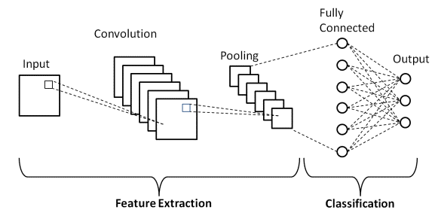

**Fig 3.1 Basic CNN Architecture: Explaining Layers Of Convolutional Neural network**

**3.2 Two phase Face mask Detector**

In order to train a custom-made face mask detector, we need to divide our project into two phases :

**1 Training:** Here we’ll focus on loading our dataset (Mask and No Mask) from disk and training a CNN model (using Keras/TensorFlow) on this dataset.

**2 Deployment:** Once the face mask detector model is trained, then we on load the mask detector prediction model, perform face detection, and then classifying each face as mask or no mask

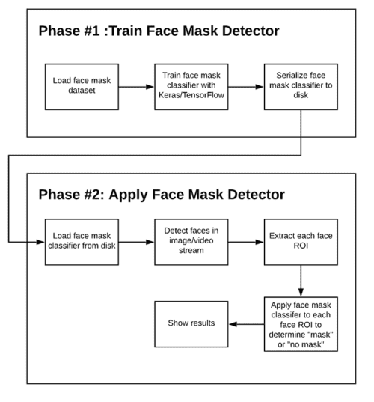

**Fig 3.2 Phases and steps for building a face mask detector with computer vision and deep learning using Python, OpenCV, and TensorFlow/Keras.**

**3.3 Algorithm**

1. Import the necessary libraries such as,

OpenCV:-

OpenCV is an open-source library for computer vision, machine learning, and image processing and now it plays a major role in real-time operation which is very important in today’s systems. By using it, one can process images and videos to identify objects, faces, or even the handwriting of humans.

TensorFlow:-

TensorFlow is an open-source platform for machine learning. It has a comprehensive, flexible ecosystem of tools, libraries, and community resources that lets researchers push the state-of-the-art in ML and developers easily build and deploy ML-powered applications.

Keras

Keras is a deep learning API written in Python, running on top of the machine learning platform [TensorFlow](https://github.com/tensorflow/tensorflow). It was developed with a aim of enabling fast experimentation.

The core data structures of Keras are **layers** and **models**. The simplest type of model is the [Sequential model](https://keras.io/guides/sequential_model/), a linear stack of layers.



**Fig 3.3.1 step 1**

1. Build the neural network (CNN)

It consists of following layers –



**Fig 3.3.2 step 2**

1. Image Generation/Data Augmentation
2. Initilizing a callback checkpoint to keep saving the best model after each epoch during training and train the model.



**Fig 3.3.3 Step 3 and 4**

1. Now load the haar cascade file using cv2.CascadeClassifier and load the pre-trained model mask_recog.h5 using load_model. Haar cascade is an algorithm that can detect faces in images. mask_recog.h5 is a pretrained model to detect objects in the image in our case it’s masks.



**Fig 3.3.4 Step 5**

Now we will test the results of face mask detector model using OpenCV i.e real time detection using a web cam



**Fig 3.3.5 Live implementation of face mask detection**

**Chapter 4**

**Result and Discussion**

**4.1 Result**

Hence we have built a face mask detection model which uses a live web cam (video stream) as an input and performs face detection as well as face mask detection in which we can see the person wearing the mask has been detected and a frame has been drawn around him and giving us information if he is wearing a mask or not.

A red rectangular frame with label ‘No Mask’ indicated person is not wearing any mask.



**Fig 4.1.1 No mask**

** Fig 4.1.2 Two people wearing no mask**

A green rectangular frame with label ‘Mask’ indicated person is wearing a mask.

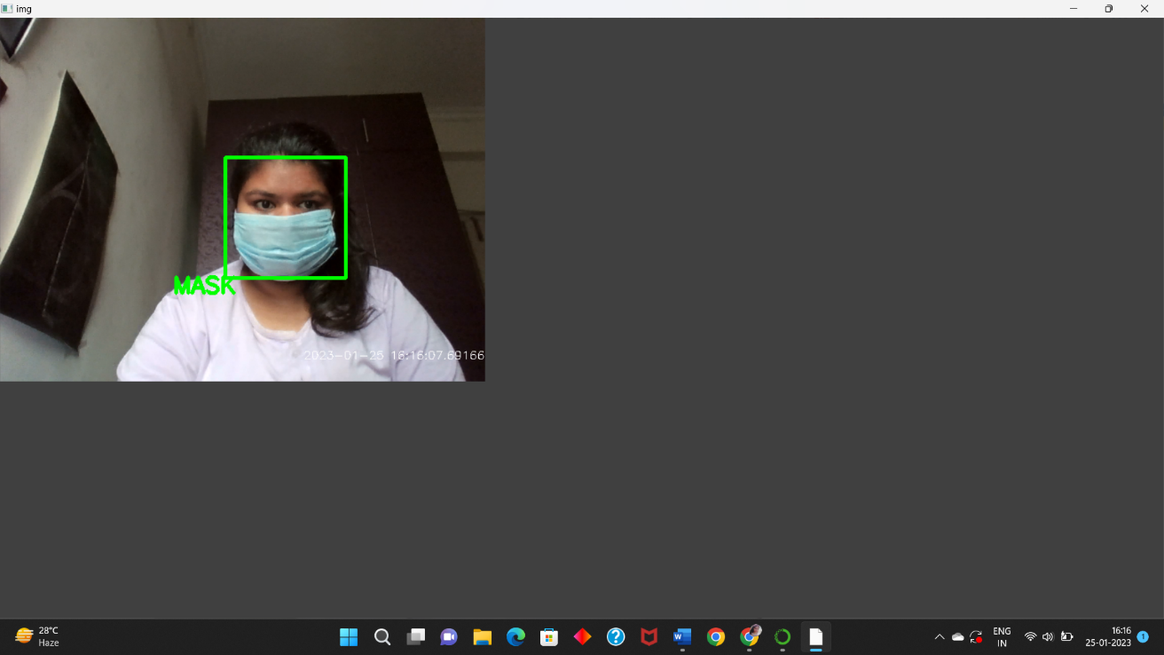 **Fig 4.1.3 Person with mask**

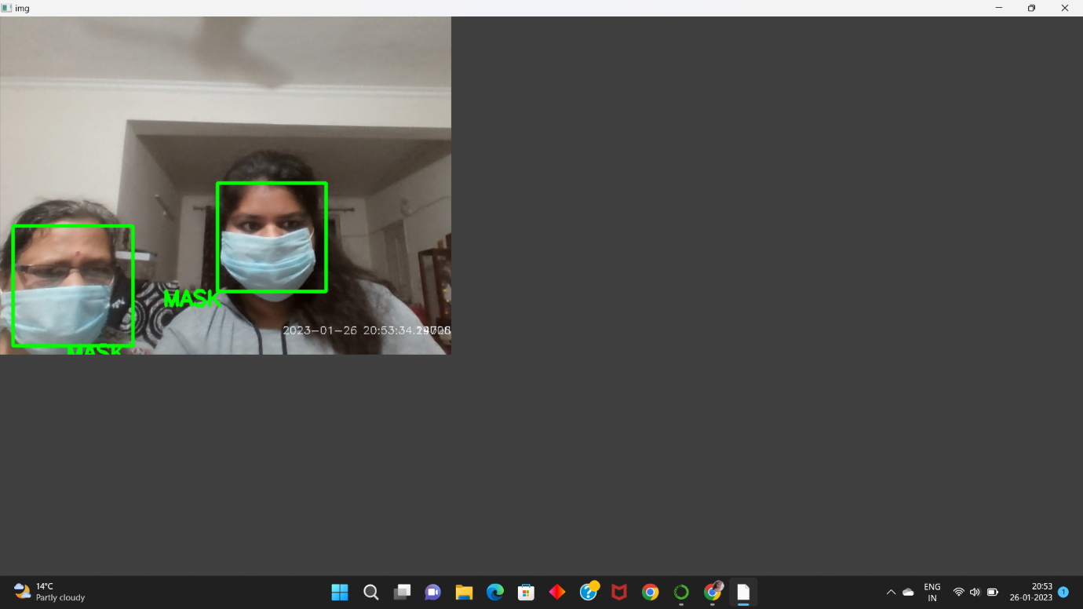 **Fig 4.1.4 Two persons with mask**

**4.2 Discussion**

The model I trained using CNN is working well. We can compare our trained model with pre-trained models available on internet and check the information about the accuracy of the model ,they have graphs that show the statistics of the model. As you can see the model can detect if the person is wearing a mask or not with precision. We can also add information like the accuracy percentage of wearing the mask and also make a third classification category ‘Mask worn incorrectly’ for cases wear mask is worn but not properly .

**Chapter 5**

**Conclusion and Future Work**

* 1. **Conclusion**

In this project, we have developed a deep learning model for face mask recognition using Python, Tensorflow ,Keras, and OpenCV. We have trained the model using Keras with a basic CNN (Convolutional neural network) architecture. Training the model is the first phase of this project and testing using webcam using OpenCV is the second phase.

Implementing this project at various fields can help detect people are wearing masks or not . This could help health authorities to implement the WHO guidelines effectively to curb covid-19 transmissios. This project is tested using a live video stream i.e. webcam using the above discussed procedure and the results are as expected.

* 1. **Future work**

In the future, this project can be used along with other AI techniques and can be implemented with systems like Autonomous Drones , to improve the efficiency and reduce the detection time .We can enhance the project by adding features like contactless temperature check, which detects proper wearing of mask and gives entry access only if the mask was worn properly and if the body temperature is normal,thus prevent the indoor spread of the virus and implement the directed safety guidelines for the prevention of Covid- 19. We can also check the type of mask whether it is surgical or N-95 and the accuracy with which it is worn. The project hold potential for further improvements and additional features can be included for using it widely in many fields.

**References**

[1] A. Das, M. Wasif Ansari and R. Basak, "Covid-19 Face Mask Detection Using TensorFlow, Keras and OpenCV," 2020 IEEE 17th India Council International Conference (INDICON), New Delhi, India, 2020, pp. 1-5, doi: 10.1109/INDICON49873.2020.9342585.

[2] Amer, Firas & Al-Tamimi, Mohammed. (2022). Face Mask Detection Methods and Techniques: A Review. The International Journal of Nonlinear Analysis and Applications (IJNAA). 13. 3811-3823. 10.22075/ijnaa.2022.6166.

[3]https://pyimagesearch.com/2020/05/04/covid-19-face-mask-detector-with-opencv-keras-tensorflow-and-deep-learning/

[4] https://data-flair.training/blogs/wp-content/uploads/sites/2/2020/07/face-mask-detector-project.gif